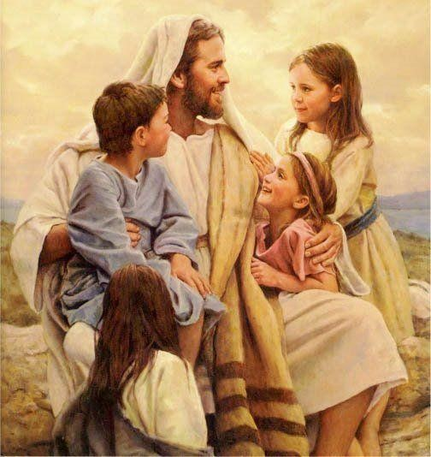
St. Mary of the Lake CCD Handbook
Father William Meininger, Pastor
“The role of the parent in (religious) education is of such importance that it is almost impossible to provide an adequate substitute.”
Catechism of the Catholic Church, #2221 Parent Responsibilities
(please check each item and then sign)
O I understand that CCD class does not substitute for Sunday Mass and plan to make weekly Sunday (Saturday) liturgy with my children a part of our lives.
O I will be responsible for my children’s prayer life by assisting them to memorize formal Prayers of the Church: Our Father, Hail Mary, Glory Be, Sign of the Cross, Apostles’ Creed, Guardian Angel Prayer, Act of Contrition and the meal blessing.
O I will actively participate in their sacramental preparation and help my children complete assignments.
O I will bring my children to class according to the schedule and assist them in completing assignments, both regular assignments and those to make up for an absence.
O I wish to grow in and live the Catholic lifestyle along with my children. O I have read this handbook and I am familiar with its contents.

_________________________________________________________
Parent/Guardian signature

(Revised August 2, 2018)

